LESSON 13.
Microbiology diagnosis of protozoan infections

LESSON PLAN:
• Classification and general characteristics of primitives.
• Classification of protozoa:
o Sarcomastigophora type:
• Sarcodina subtype:
• Entamoeba hystolitica, morpho-biological characteristics, pathogenesis, microbiological diagnosis of amebiasis (microscopic, histological, parasitological, serological methods)
• Subtype Mastigophora:
• Giardia lamblia, morpho-biological characteristics, pathogenesis, microbiological diagnosis
• Morpho-biological characteristics, pathogenesis, microbiological diagnosis of Trichomonas genus (T.vaginalis).
• Genus Leischmania (L.donovani, L.tropica), morpho-biological features, pathogenesis, microbiological diagnosis (microscopic, parasitological, serological methods)
• Causes of trypanosomosis (T. brucei, T. cruzi), morpho-biological characteristics, pathogenesis, microbiological diagnosis
• Type Apicomplexa:
• Plasmodium genus (P.malariae, P.vivax, P.ovale, P.falciparum), morpho-biological characteristics and life cycle. Pathogenesis of the disease. Microbiological diagnostics (microscopic, serological, express method)
• Toxoplasma gondii, morpho-biological characteristics, pathogenesis, microbiological diagnosis (microscopic, parasitological, serological (IFA, IFR, KBR, PHAR), skin-allergic methods)
• Ciliophora type:
• Balantidium coli, morpho-biological characteristics, pathogenesis, microbiological diagnosis
• Microspora type, Microsporidium genus – as an obligate intracellular parasite

ESTIMATED WORLDWIDE DISEASE BURDEN OF PARASITIC INFECTIONS
Medically Important Parasites
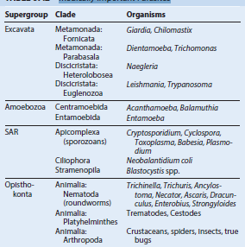

Biologic, Morphologic, and Physiologic Characteristics of Pathogenic Parasites
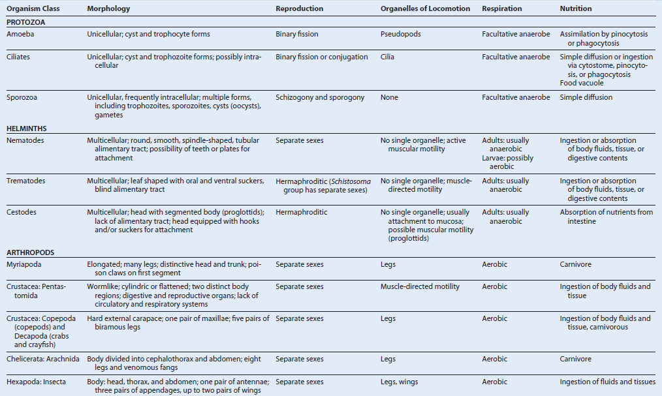

Transmission and Distribution of Pathogenic Parasites 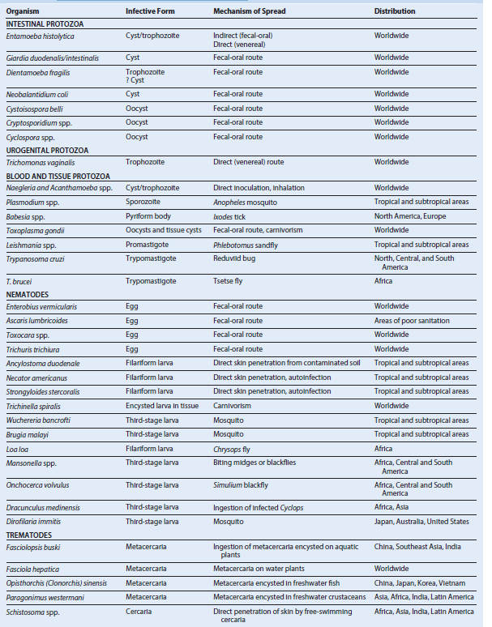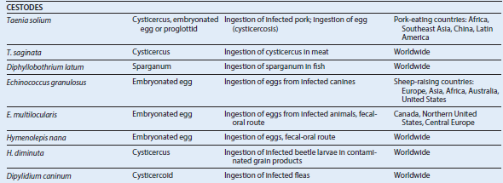
Factors Associated with Parasite Pathogenicity
Infective dose and exposure
Penetration of anatomic barriers
Attachment
Replication
Cell and tissue damage
Disruption, evasion, and inactivation of host defenses

Parasite Ports of Entry
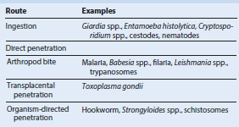

Examples of Parasitic Adherence Mechanisms
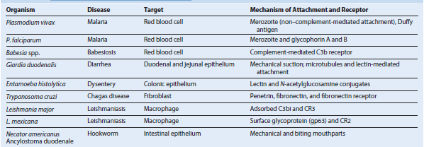

Some Pathologic Mechanisms in Parasitic Diseases

TOXIC PARASITE PRODUCTS
Hydrolytic enzymes, proteinases, collagenase, elastase - Schistosomes (cercariae), Strongyloides spp., hookworm, Entamoeba histolytica,
African trypanosomes, Plasmodium falciparum
Amebic ionophore - E. histolytica
Endotoxins - African trypanosomes, P. falciparum
Indole catabolites - Trypanosomes

MECHANICAL TISSUE DAMAGE
Blockage of internal organs - Ascaris spp., tapeworms, schistosomes, filaria
Pressure atrophy - Echinococcus spp., Cysticercus spp.
Migration through tissue - Helminthic larvae

IMMUNOPATHOLOGY
Hypersensitivity
Autoimmunity
Protein-losing enteropathies - Hookworm, tapeworm, Giardia spp., Strongyloides spp.
Metaplastic changes - Opisthorchis spp. (liver flukes), schistosomes

Immunopathologic Reactions to Parasitic Disease 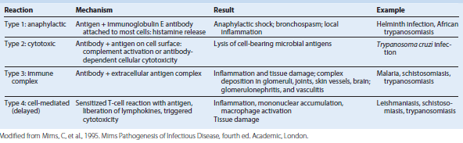

Microbial Interference with or Avoidance of Immune Defenses
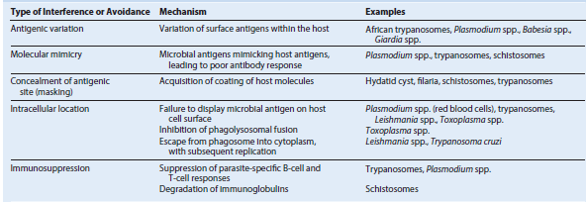

SUMMARY OF PARASITES ASSOCIATED WITH HUMAN DISEASE

BLOOD
Malaria - Plasmodium falciparum, P. knowlesi, P. malariae, P. ovale, P. vivax
Babesiosis - Babesia spp.
Filariasis - Wuchereria bancrofti, Brugia malayi, Mansonella spp., Loa loa

BONE MARROW
Leishmaniasis - Leishmania donovani, L. tropica

CENTRAL NERVOUS SYSTEM
Meningoencephalitis - Naegleria fowleri, Trypanosoma brucei gambiense, T. b. rhodesiense, T. cruzi, Toxoplasma gondii
Granulomatous encephalitis - Acanthamoeba spp., Balamuthia mandrillaris
Mass lesion, Brain abscess - T. gondii, Taenia solium, Schistosoma japonicum, Acanthamoeba spp., B. mandrillaris
Eosinophilic meningitis, Cerebral malaria - Angiostrongylus cantonensis, Toxocara spp., Baylisascaris (neural larva migrans), P. falciparum
Cerebral paragonimiasis - Paragonimus westermani

EYE
Keratitis - Acanthamoeba spp., Onchocerca volvulus
Chorioretinitis, Conjunctivitis - T. gondii, O. volvulus, L. loa
Ocular cysticercosis (mass lesion) - T. solium
Toxocariasis - Toxocara spp. (ocular larva migrans; mimics retinoblastoma)

TRACT
Anal pruritus - Enterobius vermicularis
Colitis - Entamoeba histolytica, Neobalantidium coli
Diarrhea/dysentery - E. histolytica, Giardia duodenalis (intestinalis), Cryptosporidium parvum, Cyclospora cayetanensis, Cystoisospora belli, Schistosoma mansoni, Strongyloides stercoralis, Trichuris trichiura
Toxic megacolon - T. cruzi
Obstruction, Perforation - Ascaris lumbricoides, Fasciolopsis buski
Rectal prolapse - T. trichiura

LIVER, SPLEEN
Abscess - E. histolytica, Fasciola hepatica
Hepatitis - T. gondii
Biliary obstruction - A. lumbricoides, F. hepatica, Opisthorchis (Clonorchis) sinensis
Cirrhosis/hepatosplenomegaly - L. donovani, L. tropica, Toxocara canis and T. cati (visceral larva migrans), S. mansoni, S. japonicum
Mass lesions - T. solium, Echinococcus granulosus, E. multilocularis

GENITOURINARY
Vaginitis/urethritis - Trichomonas vaginalis, E. vermicularis
Renal failure - Plasmodium spp., L. donovani
Cystitis/hematuria - S. haematobium, P. falciparum (blackwater fever)

HEART
Myocarditis - T. gondii, T. cruzi
Megacardia/complete heart block - T. cruzi

LUNG
Abscess - E. histolytica, P. westermani
Nodule/mass - Dirofilaria immitis, E. granulosus, E. multilocularis
Pneumonitis - A. lumbricoides, S. stercoralis, Toxocara spp., P. westermani, T. gondii, Ancylostoma brasiliense

LYMPHATICS
Lymphedema - W. bancrofti, B. malayi, other filaria
Lymphadenopathy T. gondii, trypanosomes

MUSCLE
Generalized myositis Trichinella spiralis, Sarcocystis lindemanni, Toxocara spp.
Myocarditis T. spiralis, T. cruzi, Toxocara spp.

SKIN AND SUBCUTANEOUS TISSUE
Ulcerative lesion - Leishmania spp., Dracunculus medinensis
Nodule/swellings - O. volvulus, L. loa, T. cruzi, Acanthamoeba spp., Toxocara spp.
Rash/vesicles - T. gondii, A. brasiliense, other migrating worms, schistosomes (cercarial dermatitis)

SYSTEMIC
General dissemination and multiple organ dysfunction - P. falciparum, T. gondii, L. donovani, T. cruzi, Toxocara spp., S. stercoralis, T. spiralis
Iron deficiency, anemia Hookworms- (A. duodenale, Necator americanus)
Megaloblastic anemia (vitamin B12 deficiency) - Diphyllobothrium latum

Chemotherapeutic Strategies That Exploit Differences between Parasite and Host
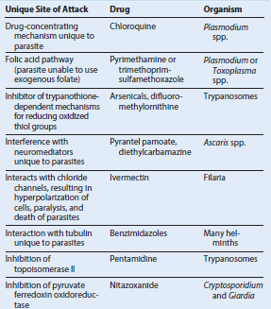

Mechanisms of Action and Clinical Indications for the Major Antiparasitic Agents
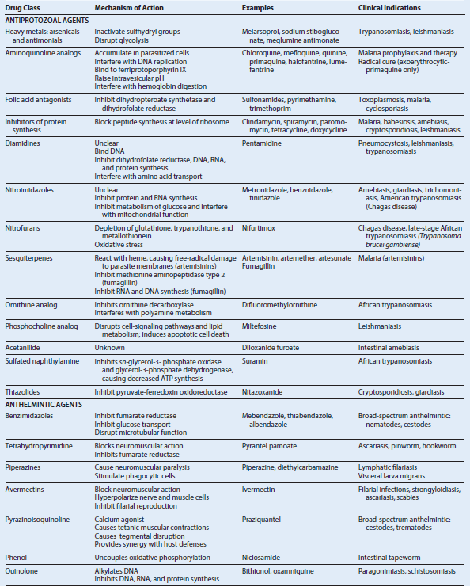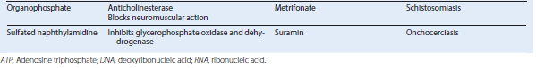

INTESTINAL AND UROGENITAL PROTOZOA

AMEBAE (AMOEBOZOA)
Trigger Words
Protozoa, amebae, trophozoite, cyst, intestinal amebiasis, extraintestinal amebiasis, hepatic amebiasis, flask-shaped ulcer, Entamoeba

Biology, Virulence, and Disease
• Primitive unicellular organisms with a simple two-stage life cycle
• Motility accomplished by extension of a pseudopod (false foot)
• Most amebae found in humans are commensal organisms
• Human pathogens: Entamoeba histolytica (most important), E.polecki

Epidemiology
• E. histolytica has worldwide distribution, with highest incidence in tropical and subtropical regions
• As many as 50% of the population in some areas are infected (average prevalence, 10% to 15%); U.S. prevalence is 4% to 5%
• Many carriers asymptomatic; pass cysts in stool (reservoir)
• Main source of food and water contamination is asymptomatic carrier who passes cysts

Diagnosis
• Microscopic examination of stool allows identification of cysts and trophozoites of E. histolytica
• Must differentiate from nonpathogenic and commensal species of amebae
• Specific serologic tests can confirm diagnosis
• Examination of stool samples may be negative in extraintestinal amebiasis
• Newer diagnostic approaches: fecal antigen, PCR, DNA probe

Treatment, Prevention, and Control
• Acute amebiasis treated with metronidazole, followed by iodoquinol, diloxanide furoate, or paromomycin
• Carrier state may be eradicated with iodoquinol, diloxanide furoate, or paromomycin
• Elimination of cycle of infection requires introduction of adequate sanitation measures, education about routes of transmission, chlorination, and filtration of water supplies
• Travelers to developing countries should avoid consumption of water (including ice cubes), avoid unpeeled fruits and raw vegetables, boil water, and thoroughly clean fruits and vegetables before consumption

CILIATES (METAMONADA [FORMERLY FLAGELLATES])
Trigger Words
Giardiasis, trichomoniasis, worm egg, contaminated stream, stool antigen test, cilia, wet mount, diarrhea, IgA deficiency

Biology, Virulence, and Disease
• Clinically important Metamonada: Giardia duodenalis (lamblia/intestinalis), Dientamoeba fragilis, Trichomonas vaginalis
• G. duodenalis life cycle has both cyst and trophozoite stages; D. fragilis has a trophozoite stage (cyst stage in mice); T. vaginalis has only a trophozoite stage
• Most flagellates move by lashing of cilia that pull organism through fluid environments
• Infection with G. duodenalis initiated by ingestion of cysts; asymptomatic carriage (50% of infected individuals); symptomatic disease ranges from mild diarrhea to a severe malabsorption syndrome
• Most infections with D. fragilis asymptomatic
• T. vaginalis causes urogenital infections
• Diseases produced by Metamonada result from mechanical irritation, inflammation of gastrointestinal and genitourinary (Trichomonas) mucosa

Epidemiology
• G. duodenalis has a worldwide distribution
• Giardiasis acquired by fecal-oral route
• Risk factors for giardiasis: poor sanitary conditions, travel to known endemic areas, consumption of inadequately treated water, day-care centers, oral-anal sexual practices
• D. fragilis has a worldwide distribution; transmission by fecal-oral and oral-anal routes
• T. vaginalis has a worldwide distribution; transmission primarily by sexual intercourse

Diagnosis
• Giardia may be detected by microscopic examination of fecal samples or duodenal aspirates
• Detection of Giardia fecal antigen by enzyme immunoassay, immunofluorescent microscopy
• Infection with D. fragilis diagnosed by microscopic examination of fecal specimens
• Trichomoniasis: microscopic examination of vaginal or urethral discharge

Treatment, Prevention, and Control
• Drug of choice for treatment of giardiasis (both symptomatic patients and carriers): metronidazole or nitazoxanide; alternatives: furazolidone, tinidazole, paromomycin, albendazole, quinacrine
• Prevention and control of giardiasis involves avoidance of contaminated water and food
• No consensus on best approach for treating D. fragilis infections; infection can be avoided by adequate sanitary conditions
• Drug of choice for trichomoniasis is metronidazole; personal hygiene, avoidance of shared toilet articles and clothing, and safe sexual practices are important preventive actions

CILIATES (CILIOPHORA)
Trigger Words
Macronucleus, pig feces, cytostome, cilia, intestinal ulceration

Biology, Virulence, and Disease
• Protozoan organisms whose locomotion involves coordinated movement of rows of hairlike structures (cilia)
• Neobalantidium coli: only Ciliophora parasite of humans
• N. coli has a funnel-like primitive mouth called a cytostome, a large and small nucleus involved in reproduction, food vacuoles, and two contractile vacuoles
• Disease produced by N. coli is similar to amebiasis; symptoms include abdominal pain, tenderness, tenesmus, nausea, anorexia, watery stools with blood and pus, ulceration of intestinal mucosa; extraintestinal infection very rare

Epidemiology
• N. coli distributed worldwide; swine and monkeys most important reservoirs
• Infections transmitted by fecal-oral route
• Outbreaks associated with contamination of water supplies with pig feces
• Person-to person spread has been implicated in outbreaks
• Risk factors include contact with swine and substandard hygienic conditions

Diagnosis
• Microscopic examination of feces for trophozoites and cysts

Treatment, Prevention, and Control
• Drug of choice is tetracycline; iodoquinol and metronidazole are alternatives
• Important preventive measures: personal hygiene, maintenance of sanitary conditions, careful monitoring of pig feces

SPOROZOA
Trigger Words
Coccidia, oocyst, chronic diarrhea, acid-fast, fecal antigen, waterborne transmission, contaminated fruits and vegetables

Biology, Virulence, and Disease
• Sporozoa constitute a very large group of protozoa called Apicomplexa or Coccidia
• All sporozoans demonstrate typical characteristics: asexual (schizogony) and sexual (gametogony) reproduction; share alternative hosts
• Intestinal sporozoan: Cystoisospora belli, Sarcocystis spp., Cryptosporidium spp., Cyclospora cayetanensis
• C. belli: coccidian parasite of intestinal epithelium; causes malabsorption syndrome
• Sarcocystis spp. can be detected in stool samples; nausea, abdominal pain, and diarrhea after ingestion of infected meat; muscular infections can occur if sporocysts ingested
• Cryptosporidium spp. cause intestinal disease, usually self-limited enterocolitis characterized by watery diarrhea without blood
• Cyclospora: illness self-limited in immunocompetent hosts, prolonged in HIV infected individuals

Epidemiology
• Cystoisospora organisms distributed worldwide; disease frequent in patients with AIDS; infection reported with increasing frequency in both healthy and immunocompromised patients
• Sarcocystis spp. are isolated from pigs and cattle
• Cryptosporidium spp. are distributed worldwide
• C. hominis and C. parvum cause most human infections; C. ubiquitum and C. felis are emerging human pathogens
• Cyclospora: worldwide distribution; infection acquired through contaminated water; U.S. outbreaks correlated with consumption of contaminated fruits and vegetables

Diagnosis
• C. belli infection best diagnosed by careful examination of concentrated stool sediment
• Sarcocystis spp. sporocysts may be detected in human stool specimens
• Cryptosporidium spp. may be detected in unconcentrated stool specimens from immunocompromised patients with diarrhea
• Diagnosis of cyclosporiasis is based on microscopic detection of oocysts in stool
• Both Cryptosporidium and Cyclospora infections may be diagnosed by PCR

Treatment, Prevention, and Control
• C. belli: treatment of choice is trimethoprim-sulfamethoxazole; prevention and control effected by maintaining personal hygiene and sanitation, avoiding oral-anal sexual contact
• No known treatment for intestinal or muscular sarcocystosis in humans
• No broadly effective therapy has been developed for managing Cryptosporidium infections in immunocompromised patients; nitazoxanide is approved by the FDA for the treatment of cryptosporidiosis in nonimmunocompromised individuals older than 12 months
• Cyclosporiasis has been treated with modest success using trimethoprimsulfamethoxazole

BLOOD AND TISSUE PROTOZOA

PLASMODIUM
Trigger Words
Malaria, quotidian, tertian, quartan, blackwater fever, cerebral malaria, benign tertian, malignant tertian, multiple ring forms, gametocytes, Anopheles mosquito, tropics and subtropics, prophylaxis

Biology, Virulence, and Disease
• Plasmodia: coccidian or sporozoan parasites of RBCs
• Five species that infect humans share a common life cycle
• Routes of acquisition: mosquito, transfusion, needle sharing, congenital
• P. falciparum produces daily (quotidian) chills and fever with nausea, vomiting, diarrhea progressing to tertian (36 to 48 hours) periodicity with fulminating disease (malignant tertian); no persistent liver stage
• P. knowlesi produces daily (quotidian) fever, chills, headache, rigors, abdominal pain, cough (severe symptoms in 7% of cases; respiratory distress and hepatorenal failure); no persistent liver stage
• P. vivax causes “benign tertian malaria” with paroxysms of fever and chills every 48 hours; a spectrum of severe, life-threatening syndromes similar to that with P. falciparum may be seen; a liver stage may cause relapses and recrudescence’s
• P. ovale causes benign tertian malaria similar to that of P. vivax with both relapses and recrudescence
• P. malariae has a long (18 to 40 days) incubation period and causes a moderate to severe disease with a 72-hour (quartan or malarial malaria) periodicity; no persistent liver stage

Epidemiology
• Infection with Plasmodium spp. Accounts for 216 million episodes with approximately 500,000 deaths annually, 90% of which are in Africa
• Vector is the Anopheles mosquito, which is widely distributed in tropical, subtropical, and temperate regions
• P. falciparum: occurs almost exclusively in tropical and subtropical regions
• P. knowlesi: infects Old World Monkeys, and increasingly humans, in Malaysia and neighboring countries throughout Southeast Asia
• P. vivax: widest geographic distribution (tropics, subtropics, temperate regions); 80% of cases occur in South America and Southeast Asia
• P. ovale: distributed primarily in tropical Africa; also found in Asia and South America
• P. malariae: occurs in same tropical and subtropical areas as other malarial parasites but less prevalent

Diagnosis
• Most widely used method: detection of parasites in thick and thin blood filmsstained with Giemsa or Wright stain
• Antigen detection using an RDT; used in both the field and diagnostic laboratories as an adjunct to microscopic examination of blood films

Treatment, Prevention, and Control
• Treatment of malaria is based on history regarding travel to endemic areas, prompt clinical review and differential diagnosis, accurate and rapid laboratory work, and correct use of antimalarial drugs
• Chloroquine or parenteral quinine is drug of choice for susceptible strains of Plasmodium; widespread resistance to chloroquine seen with P. falciparum and P. vivax
• Chemoprophylaxis with chloroquine, doxycycline, Malarone, or mefloquine coupled with avoiding mosquito bites (netting, insect repellents, clothing) required for prevention
• Elimination of mosquito breeding places
TOXOPLASMA GONDII
Trigger Words
Cat feces, raw meat, lymphadenitis, CNS lesion, encephalomyelitis, cat litter, congenital infection, AIDS

Biology, Virulence, and Disease
• Typical coccidian intracellular parasite found in a wide variety of animals, including birds and humans
• Essential reservoir host: common house cat and other felines
• Most T. gondii infections asymptomatic
• Symptoms occur when parasite moves from blood to tissues; include fever, chills, headaches, myalgia, lymphadenitis, fatigue
• Chronic disease marked by hepatitis, encephalomyelitis, and myocarditis
• Chorioretinitis may lead to blindness
• Congenital infection has serious sequelae
• Reactivation of cerebral toxoplasmosis is a major cause of encephalitis in patients with AIDS

Epidemiology
• Human infections ubiquitous
• Infection from ingestion of improperly cooked meat from intermediate-host animals or ingestion of infective oocysts from contaminated cat feces
• Transplacental infection can occur during pregnancy
• Rate of severe infection affected by patient’s immune status
• Illness in immunocompromised host believed to be caused by reactivation of previously latent infection rather than
new exposure to organism
Diagnosis
• Increasing antibody titers documented inserially collected blood specimens
• Panel of tests (TSP) is used to determine recent versus past acquisition of infection
• Diagnosis of Toxoplasma encephalitis usually involves imaging study of brain
• Microscopy, serologic, and moleculartechniques may be required for definitive diagnosis

Treatment, Prevention, and Control
• Treatment of choice: initial high-dose regimen of pyrimethamine plus sulfadiazine followed by lower doses of both drugs indefinitely (AIDS patients and other immunocompromised patients)
• Clindamycin or spiramycin may be used in first trimester of pregnancy
• High-risk patients may be considered for prophylaxis
• Additional preventive measures: avoid consumption and handling of raw or undercooked meat, avoid exposure to cat feces

LEISHMANIA
Trigger Words
Kala-azar, Dumdum fever, cutaneous and mucocutaneous disease, visceral leishmaniasis, sand fly, post–kala-azar dermal leishmaniasis

Biology, Virulence, and Disease
• Leishmania: obligate intracellular parasites transmitted from animal to human or human to human by bites from infected female sand fly
• Many different species can infect humans, producing a variety of diseases (cutaneous, diffuse cutaneous, mucocutaneous, visceral)
• Clinical syndromes depend on species involved; most common species: cutaneous (L. tropica), mucocutaneous (L. braziliensis), visceral (L. donovani, L. infantum), post–kala-azar dermal leishmaniasis (L. donovani)

Epidemiology
• Natural reservoirs: rodents, possums, anteaters, sloths, dogs, cats
• Infection may be transmitted by animalvector- human or human-vector-human cycle, by direct contact with infected lesion, or mechanically by flies
• Mucocutaneous leishmaniasis most often occurs in Bolivia, Brazil, Peru; cutaneous leishmaniasis much more widespread throughout Middle East and in focal areas of South America
• Visceral leishmaniasis (kala-azar, Dumdum fever): ≈50,000 cases per year, 90% localized to Bangladesh, Brazil, India, Nepal, Sudan

Diagnosis
• Diagnosis of visceral, cutaneous, or mucocutaneous leishmaniasis made on clinical grounds in endemic areas
• Definitive diagnosis depends on detecting amastigotes in clinical samples or promastigotes in culture; molecular techniques have been used for diagnosis, prognosis, and species identification
Treatment, Prevention, and Control
• Drug of choice for all forms of leishmaniasis is the pentavalent antimonial compound sodium stibogluconate (Pentostam)
• Fluconazole and miltefosine efficacious in cutaneous disease
• Stibogluconate remains drug of choice for mucocutaneous leishmaniasis
• Prevention involves prompt treatment of human infections and control of reservoir hosts, along with vector control

TRYPANOSOMES
Trigger Words
Sleeping sickness, tsetse fly, reduviid bugs, chagoma, Romaña sign, megaesophagus, Winterbottom sign, Chagas disease

Biology, Virulence, and Disease
• Trypanosoma, a hemoflagellate, causes two distinctly different forms of disease: African trypanosomiasis and American trypanosomiasis
• African trypanosomiasis (sleeping sickness): chronic disease of several years’ duration, transmitted by tsetse flies, fatal without treatment
• American trypanosomiasis (Chagas disease): asymptomatic, acute, or chronic forms, transmitted by reduviid bugs

Epidemiology
• T. brucei gambiense limited to tropical West and Central Africa, correlating to range of tsetse fly vector
• T. b. rhodesiense found in East Africa, especially cattle-raising countries
• Domestic and wild game animals act as reservoir hosts for T. b. rhodesiense
• T. cruzi occurs widely in both reduviid bugs and a wide variety of reservoir animals in North, Central, and South America
• Because of the chronic nature of infection, screening of solid organ and blood donors for Chagas disease has become important

Diagnosis
• Agents of sleeping sickness can be demonstrated in blood films, aspirations from lymph nodes, and concentrated spinal fluid
• T. cruzi can be demonstrated in blood films early in acute stage of disease

Treatment, Prevention, and Control
• Suramin: drug of choice for treating acute blood and lymphatic stages of both Gambian and Rhodesian forms of sleeping sickness; pentamidine is an alternative
• Melarsoprol: drug of choice for CNS disease
• Effective control measures: integrated approach to reduce human reservoir of infection, use of fly traps and insecticide
• Drugs of choice for treatment of Chagas disease: benznidazole and nifurtimox
• Vector control important: insecticide, eradication of nests, construction of homes to prevent nesting of bugs
CNS, Central nervous system; PCR, polymerase chain reaction; RBC, red blood cell; RDT, rapid diagnostic test; TSP, T. gondii serologic profile.

MEDICALLY IMPORTANT BLOOD AND TISSUE PROTOZOA
Plasmodium species
Babesia species
Toxoplasma species
Sarcocystis species
Acanthamoeba species
Balamuthia species
Naegleria species
Leishmania species
Trypanosoma species

Human Malarial Parasites
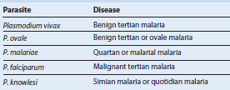

Leishmaniasis in Humans
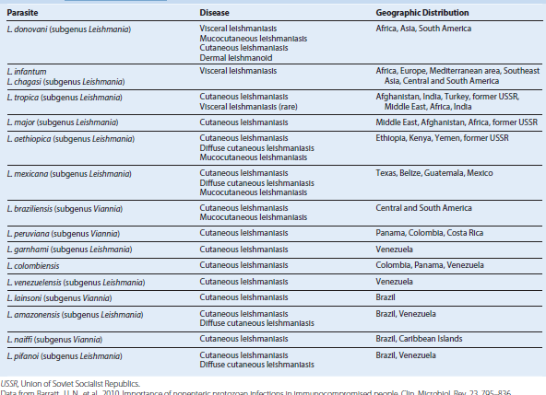

Trypanosoma Species Responsible for Human Diseases